How Leadership Teams Can Recover from Toxicity
As published in Chief Executive Magazine on June 6, 2019
By Jack McGuinness, Managing Partner of Relationship Impact

Building a great leadership is hard work which is made even harder when teams and individual team members struggle to move on from past toxic experiences. In this article we will provide our perspective on how leadership teams can recover from toxic environments. We start by presenting the symptoms of toxicity and our view on what leads to these unhealthy and unproductive environments and then we discuss what actions can be taken to help leadership teams recover.

Toxic or even moderately dysfunctional leadership teams can cause long-term harm to leadership team members and their employees. Symptoms of toxic leadership team environments might include cynicism, defensiveness, lack of trust, heightened reactions to minor issues, avoidance, and passive aggressiveness, among other destructive behaviors. Individuals develop coping mechanisms in these environments which often become new ways of operating. The following are a few examples drawn from our client work: ‘if you make sacrifices for the good of the company it will hurt your department’; ‘if you reveal a weakness the CEO will hold it against you’; ‘in order to get approval from the CFO you have to act like it was his idea’. Even when well-intentioned efforts are made to address toxic environments such as replacing the leader, terminating toxic teammates or restructuring, the path to recovery can be quite challenging.
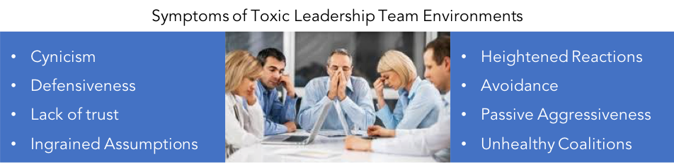

Toxic Leadership Teams
In our experience there are three common issues that contribute to toxic leadership team environments. One of the most pervasive and perhaps one of the most destructive issues is tolerance of bad behavior from high performers – ‘As long as Bob keeps hitting his numbers, we can overlook his arrogant behavior.’ In essence leadership teams wind up living by two sets of rules which leads to frustration, resentment and infighting. Another factor that contributes to leadership team toxicity is destructive CEO behavior. CEOs set the tone for their leadership teams and when they micromanage, lash out emotionally, always need to be right, don’t like to be challenged, or hold grudges, their teams suffer greatly. In fact, executive coaching guru Marshall Goldsmith devoted an entire book to the 20 Bad Habits of Senior Leaders in his book “What Got You Here Won’t Get You There.” Bad CEO behavior can stifle team member development, hinder innovation, and lead to unhealthy competition among team members and their departments. A third common issue that fuels toxic leadership team environments is a focus on ‘what gets done’ at the expense of ‘how something gets done’ – ‘We can clean up the mess later, let’s just get it done.’ This ‘results at any cost’ mantra can be extremely dangerous as it often leads to a common practice of short cuts and circumventing rules. Short-term focus can also hinder a leadership team’s ability to pay attention to emerging trends and strategic actions that enable organizations to compete and grow.

“Even when well-intentioned efforts are made to address toxic environments… the path to recovery can be quite challenging.”

The Path to Recovery
Beyond obvious business impacts, the long-term effects stemming from leadership team toxicity are hard to overcome. New ways of operating that individuals establish to cope with challenging environments coupled with ingrained assumptions teammates make about one another become strong barriers to recovery. A key to moving from a toxic environment to building a great team that is resilient, laser focused on results, and productively addresses increasingly complex challenges is acknowledgement. CEOs must help their teams recognize that structural solutions alone – termination, tweaking roles, changing the structure – will not be sufficient. Recovery requires a commitment to addressing damaged relational dynamics including recalibrating ingrained assumptions and rebuilding trust which are both easy to say but really hard to do!

“When team members see the CEO demonstrating vulnerability – admitting mistakes and committing to change – they are much more likely to take steps to change themselves.”

Ingrained assumptions must be dealt with for a team to start on the path to recovery. The challenge is that while sometimes assumptions are true often times they are not. Teammates might assume, for example, that the CFO is arrogant and aloof because she keeps to herself and just seems to ignore the dysfunction. But what if the assumption is wrong and the CFO has a tough time with conflict and deals with dysfunction best by digging into to her work? An even bigger challenge is when assumptions are right on target – ‘Bob always seems to renegotiate team decisions with the CEO.’ When Bob finally recognizes the impact of this bad behavior, many teammates will maintain their original assumptions and not trust any attempts Bob makes to change. Recalibrating assumptions is a key factor in repairing trust on toxic leadership teams.

The balance of this article describes an approach many of our clients have used to reduce the lingering impacts of toxic leadership team environments after they have taken initial steps to address bad behaviors.

Step One - Leadership
The first step in the path to recovery is strong leadership. CEOs need to help their teams acknowledge that they are all likely still suffering from the impacts of an unhealthy and unproductive environment. CEOs also have to emphasize that the work now is to look forward and do whatever it takes to build a great team with a healthy environment. Another crucial step CEOs have to take is to acknowledge their role in the dysfunction and begin to model new behaviors such as committing to listen to feedback, empowering team members, and holding individuals accountable to the same set of rules. When team members see the CEO demonstrating vulnerability – admitting mistakes and committing to change – they are much more likely to take steps to change themselves.

Step Two – Understand the Challenge & Reset Expectations
The next step is for the team to identify and gain agreement on the symptoms of toxicity that are impacting them. CEOs should convey that any structural changes such as termination or redefining roles will be insufficient until the team understands the roots of the relational damage. To get to the root of the dysfunction, the CEO should present his/her view of the root issues – ‘we have had two sets of rules’; ‘I have stifled dialogue’; ‘we haven’t had clarity on roles’ – and ask each team member to provide further input. After gaining a collective understanding of the challenge, the team should spend some time to reset expectations for how they want their team to operate – ‘assuming that the team is working great six to twelve months from now what will it look and feel like?’ Once the challenge is clear and the expectations are clear they can begin to do the hard work as a team and individuals to begin to build a healthier and more productive environment.

“Trust is like the air we breathe. When it is present, nobody notices. But when it’s absent, everybody notices.” – Warren Buffet

Step Three – Rebuild Trust
An earlier article we wrote for Chief Executive Magazine called Trust is What Fuels Great Leadership Teams suggests that trust consists of three main components – trust in another’s competence, character and dependability. Each takes a big hit on toxic leadership teams and trust is an extremely difficult thing to rebuild. To start the rebuilding process, team members have to acknowledge any contribution they have made to an unhealthy atmosphere; even if as simple as not speaking up about concerns or talking negatively about teammates. Demonstrating this type of vulnerability begins to loosen the tension – ‘I recognize that renegotiating team commitments with the CEO makes you feel like I am going behind your back.’

Next, individuals have to evaluate the assumptions they have made about their teammates and take steps to test whether the assumptions are true or not. One type of assumption is what we refer to as the ‘hangover’ effect – despite the induction of a new CEO with a hands-off, empowering approach some team members still behaved as if he was micromanaging – ‘why is he asking that,’ ‘how come he’s provides so much detail in his email responses.’ Other assumptions are based on the behaviors team members see from their colleagues related to competence, character or dependability. ‘she has no idea what she is doing because she asks too many questions and takes too long to get to the point.’ This certainly may be a development challenge, but it is not necessarily a question of competence. Trust can begin to be repaired when teammates start to discuss the behaviors they are seeing that contribute to assumptions and begin to dig deeper to understand the motivations and intent behind the behaviors – ‘now I recognize that you are detail oriented and always seeking to get to the best course of action.’

After leadership teams take time to demonstrate vulnerability and test their assumptions, it is critical that they make collective and individual commitments to strengthen how the team operates. When teams are recovering from a toxic environment a good practice is to establish a set of behavioral operating principles that serve as a foundation for holding each other accountable. Operating principles might range from ‘we will actively support the decisions made by the team’ to ‘we will not speak negatively about our teammates behind their backs’ to ‘we will talk directly to our colleagues about any challenges.’ Based on their self-reflection and the feedback they are receiving from teammates; each individual should make specific behavioral commitments designed to help strengthen how the leadership team operates. An example commitment might include: ‘I commit to adhere to team decisions and will not try to renegotiate for my benefit outside of the team construct and when I don’t live up to this commitment please give me feedback.

“Trust can begin to be repaired when teammates… dig deeper to understand the motivations and intent behind the behaviors”

Embracing what Carol Dweck refers to as a growth mindset can help with this commitment making approach and help us unlock our ingrained assumptions. A growth mindset is a belief that learning and intelligence can grow with time and experience which is quite different from what Dweck refers to as a fixed mindset or belief that an individual’s qualities are fixed and therefore cannot change. Below is a graphic that illustrates the shift in behaviors and mindset that can help leadership teams begin to repair trust.
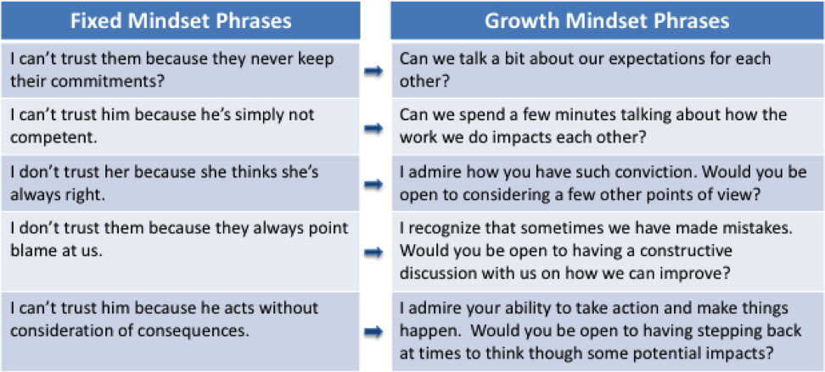

Recovering from toxic leadership team environments is not easy and requires nurturing and commitment on the part of every team member. Strong leadership from the CEO will set the tone for recovery and enable team members to self-evaluate and make commitments necessary to address the toxicity and begin to build a healthy and productive environment.

