Great Leadership Teams Optimize Collaboration
As published in Chief Executive Magazine on June XX, 2019
By Jack McGuinness, Managing Partner of Relationship Impact

Collaboration is one of those 'obvious' things that leadership teams are supposed to be good at. Unfortunately, many struggle to find an optimal balance between working independently and working collaboratively. Some teams view collaboration as something that gets in the way of executing the work while others feel the need to collaborate and ensure that everyone's voice is heard all of the time. This article sheds some light on how great leadership teams view collaboration - they collaborate when they need to and don't when they don't!

Collaboration Struggles
There are a number of factors that contribute to why some leadership teams struggle to collaborate. One factor is autonomy – often defined as feeling like you have a choice in how to achieve your day-to-day work. Executives are no different than most employees who value and derive great satisfaction from autonomy. Fortunately, as suggested by a recent Slack organizational study, autonomy can drive effective collaboration as it tends to yield new ideas which often require input, debate and experiment with others. The pace and complexity of today’s business environment can also impede leadership team collaboration as it is often more efficient to ‘go forth and execute’ rather than take the time to share information, debate divergent viewpoints and gain agreement on a plan of attack. Another factor that hinders leadership team collaboration is the faulty assumptions that executives make. For example, some executives believe that collaboration means that everyone’s input needs to be heard on all issues, conflict gets in the way, or the team needs to reach consensus on all issues.

“…people working collaboratively stuck at their task 64% longer than those working individually on the same task.”

Effective Collaboration
A Stanford University study found that people working collaboratively stuck at their task for 64% longer than those working individually on the same task. It also reported higher levels of engagement and success and lower levels of fatigue. Creating an environment that encourages everyone to work together can have a big impact on a leadership team’s performance. Finding the right balance between autonomous working and collaboration will help to play to each team member’s individual strengths and keep the team engaged and efficient. Below is a graphic from the Slack organizational study mentioned above.

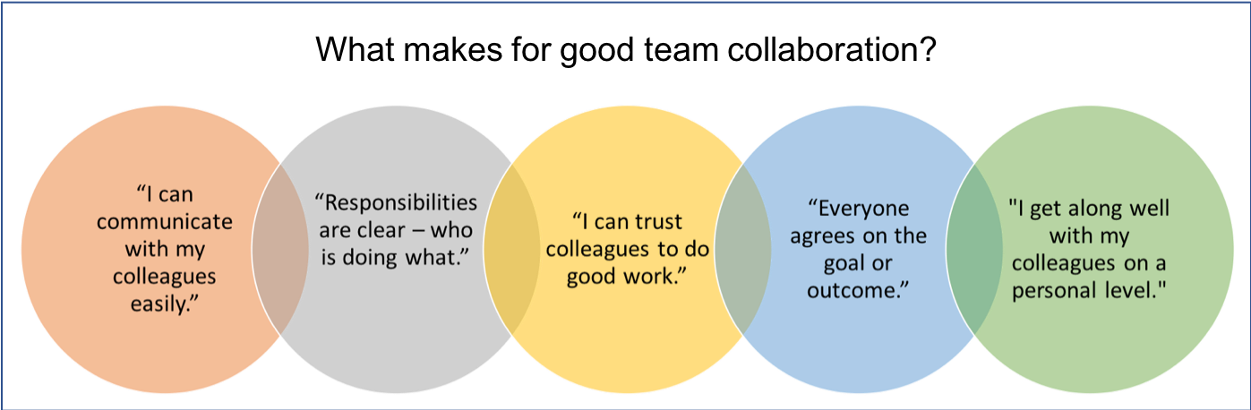

To go beyond the basic principles of good collaboration – curiosity, listening, sharing information, give and take of ideas – and truly optimize how a leadership team collaborates, teams need to take time to define purpose, agree on how they are going to integrate, and reinforce collaboration principles. The balance of this article articulates our approach to helping leadership teams optimize how they collaborate.

Agree on what work requires collaboration. There is no doubt that leadership teams are stewards for the organization’s mission and strategy, and it is important that they keep each other informed, provide input and monitor progress. However, this stewardship role does not provide adequate guidance for how a team should behave and operate as a unit. A leadership team’s purpose should address the priority issues that require the team’s collective, cross-boundary expertise such as key strategic imperatives (i.e., reduce customer concentration risk, strengthen operations to prepare for dramatic growth), cross organizational resource allocation, or how to capture synergies across business units. Over time the best leadership teams develop an intrinsic sense for when they need to collaborate and when it is in the best interest of the team to work independently. These teams have a clear sense of what their purpose is as a leadership team and how they will work together to leverage the unique talents and experience of each team member to achieve that purpose.

“Over time the best leadership teams develop an intrinsic sense for when they need to collaborate and when it is in the best interest of the team to work independently.”

Gain clarity on roles and how to integrate. After defining the team’s purpose, team members have to discuss and clarify their individual roles in driving the purpose – Who is going to lead each priority area?, What specific contributions will each team member make?, Is it necessary for all team members to be involved in all aspects of execution? The team then needs to gain agreement on how they are going to integrate – Which roles have the greatest dependencies? How are the ambiguous gray areas going to be handled? Taking on this definitional work is important but our experience suggests that the true benefit is in the discussions that team members have to drive clarity. There is no perfect script for how a team works together but when they are able to challenge, debate and confront each other well trust is strengthened, and the team becomes more resilient.

Reinforce collaboration principles. Once a leadership team gains a good understanding of what work requires collaboration and how the team is going to work together, it is important for the team to discuss and gain agreement on behaviors they expect of each other. Again, the discussion is more important than the actual list of behaviors identified. While the following list is certainly not exhaustive, our experience suggests that these five principles support effective collaboration.
- Communication. One of the most important principles behind good collaboration is communication. To collaborate effectively, team members have to express themselves well to each other including being direct and clear and ensuring tone and body language support their messages.
- Listening. There is perhaps no greater sign of respect in our interactions with teammates than listening attentively. When we listen to our colleagues, we send all sorts of positive signals that reinforce collaboration – ‘I care about you’ - ‘I understand you’ - ‘I value you’ - ‘you are important.’
- Feedback. The ability to give and receive feedback well is one of the keys to moving important priorities forward. When we provide constructive input to our teammates in a helpful ‘this is my point of view’ rather than ‘I am definitely right’ manner we encourage them to engage. When we listen to input from our colleagues with curiosity rather than defensiveness or emotion, we enable more productive dialogue.
- Compromise. To move important priorities forward productively, team members simply have to be able to compromise with each other. When individuals work hard and seek to understand the perspectives of their colleagues, solutions are more innovative and productive and team relationships are reinforced.
- Dependability. Effective collaboration requires trust and a key component of trust is dependability. Each individual has to do their very best to live up to the commitments they make to their teammates. Leadership teams comprised of dependable colleagues who are reliable and hold each other accountable tend to achieve more predictable results.

Great leadership teams optimize collaboration. In simple terms they know when it is important for the team to operate together and, perhaps most importantly, they know when it is not necessary for the team to collaborate. Over time great leadership teams optimize collaboration naturally without much thought. However, to build this skill great leadership teams take time to discuss and define their purpose as a team, clarify their roles and where integration will be most impactful, and discuss and reinforce important collaboration principles.

